**Career Anchors**

a. What is a career anchor?

One element in a person's self-concept that she will not give up, even in the face of difficult stories

b. What three aspects of a person do career anchors cover holistically?

* What are my talents, skills, and areas of competence? What are my strengths and weaknesses?

c. How many career anchors are there? Please explain in brief what each career anchor stands for.

* 8 Career Anchors
* TF (Technical/Functional Competence)
  + Expert, Specialization
  + Intrinsically rewarding
  + Promotion -> Conflict
* GM (General managerial Competence)
  + Management per se
  + Specialization as obstacle
  + Reach the top
  + Skills required Analytical, Interpersonal, emotional
* AU (Autonomy/Independence)
  + Own way
  + Independent careers
  + No close supervision
  + Contract/project work
* SE (Security/Stability)
  + Safety
  + Secure
  + Tenure
  + Goldenhandcuffs
* EC (Entrepreneurial Creativity)
  + Create new
  + Pursuing dreams
  + Relentlessly
* SV (Service/Dedication to a cause)
  + Serving others
  + Improving the world
  + Serving humanity
* CH (Pure Challenge)
  + Conquering anything
  + Overcoming obstacles
  + Challenge
* Ls (Lifestyle)
  + No career anchor?
  + Total lifestyle integration

d. How much time does it take on average to identify your career anchor? Why so long? Can you speed up the process?

* Around 10 years of work experience
* You have to learn their talents, motives and values
* Yes, if a person has many varied experiences and gets meaningful feedback in each one, it can develop more qucikly.

e. How is the concept of Career Anchors relevant to Strategic Management?

* It can help develop more befitting positions for strategic tasks
* Understanding the characteristics of a role, job, or career that individuals are drawn to.
* Important to separate cases of misfits vs. poor performers
  + Framework is meant to help employers find out misfits and redefine their roles/positions
* Can help increase employee satisfaction and consequently their productivity

**Leadership Styles**

1. Briefly describe 7 leadership types identified by Plato.
   1. Shepherd
      1. Notion of care, tending their flock, protecting it from dangers, Servant to their subjects
   2. Doctor
      1. Service of their patients focusing first and foremost on their wellbeing, thinking of various social and institutional ills that the leader might have to remedy, specialized skill required
   3. Navigator
      1. Steers the passengers and crews through choppy water, the idea of unpredictable dangers, specialized skill required
   4. Artist
      1. Visionary, inspirational
   5. Teacher
      1. Informing people, educating them. The relationship between leader and led is more intellectual than in the case of the shepherd, doctor, or navigator
   6. Weaver
      1. Uniting several different strands of wool into a single garment, recruiting the right people, despite their very diverse talents and temperaments, bringing them together into a unified team
   7. Sower
      1. Taking a slightly hands-off approach, generating ideas and initiatives for others to take up and then develop, nurturing these ideas, happy for other to take the lead
2. Which leadership type is the most praiseworthy according to Plato? Why so?

* All are important one is no better than another, however the sower is the highest level because they are making new leaders .

1. Mention 6 main contemporary leadership styles, and outline their one advantage and disadvantage.
   1. Authoritarian
      1. Imposing expectations and defining outcomes. A one-person show can turn out to be successful in situations when a leader is the most knowledgeable in the team, when a team member needs clear guidelines and are time-constrained. However, creativity will be sacrificed since input from the team is limited
         1. Advantage
            1. Reduced time spent on making decisions
            2. Chain of command clearly emphasized
            3. Reduced Mistakes in the implementation
            4. Can create consistent results
         2. Disadvantages
            1. Can evoke employee rebellion
            2. Kills employee creativity and innovation
            3. Reduces group synergy & Collaboration
            4. Decreases group input significantly
            5. Increases employee turnover rate
   2. Participative
      1. Involving team members in the decision making process, making them feel included, engaged and motivated to contribute.
         1. Advantages
            1. Increases employee motivation and job satisfaction
            2. Encourages employee creativity
            3. Helps creating a strong team
            4. Can achieve high level of productivity
         2. Disadvantage
            1. Decision making process becomes time-consuming
            2. Leaders have a high probability of being apologetic to employees
            3. Communication failures often happen
            4. Security issues can arise due to transparency in information sharing
            5. Poor decisions can be made in case the employees are unskilled
   3. Delegative
      1. Focuses on delegating initiative to team members.
         1. Advantage
            1. Innovation & Creativity are highly valued
            2. Creates a positive work environment
            3. Experienced employees can take advantage of their competence and experience
         2. Disadvantages
            1. Responsibility is not properly defined
            2. More difficult to adapt to change
   4. Transactional
      1. Uses ‘transactions’ between a leader and their followers- rewards, punishments and other exchanges- to get the john done
         1. Advantages
            1. Creates specific measurable and time bound goals that are achievable for employees
            2. Employee motivation and productivity is increased
            3. Eliminates or minimizes confusion in the chain of command
            4. Creates a system that is easy to implement for leaders and easy to follow by employees
            5. Employees can choose reward systems

* Disadvantages
  + Innovation and creativity is minimized
  + Empathy is not valued
  + Creates more followers than leaders among employees
  1. Transformational
     1. Inspires followers with a vision and then encourages and empowers them to achieve it. Leader is the role model.
        1. Advantages
           1. Leads to a lower employee turnover rate
           2. Places high value on corporate vision
           3. Can achieve high morale of employees
           4. Uses motivation and inspiration to gain the support of employees
           5. Not a coercive approach to leadership
           6. Places high value on relationships
        2. Disadvantages
           1. Leaders can deceive employees
           2. Consistent motivation and constant feedback may be required
           3. Tasks can’t be pushed through without the agreement of employees
           4. Can sometimes lead to the deviation of protocols and regulations
  2. Servant
     1. Main goal and responsibility is to provide service to employees
        1. Advantage
           1. Decisions are based of benefit of all
           2. Encourages empathy
           3. Encourages diversity within the workplace
           4. Customers win too
        2. Disadvantage
           1. Focusing on the immediate employees rather than the company as a whole
           2. The role of the leader is lessened serving others’ needs
           3. Decisions take longer to be made
           4. It may require retraining

1. Key considerations on Leadership
   1. Leadership positions vs. being a leader
   2. Leader vs. manager
   3. A contemporary view on leadership
      1. Visionary + Charismatic + Transformational

**Intellectual Assets**

* What is Intellectual Capital?
  + Is a measure of the value of a firm’s intangible assets. It is the difference between a firm’s market value and book value
* What is ‘investing in a company’ primarily about?
  + Buying a set of talents, capabilities, skills and ideas, intellectual capital, not as much physical and financial resources
* Human Capital: its three pillars, and key insights per pillar.
  + Attracting Human Capital
    - Recognize the geographical preferences of talent
    - Attract new generations
  + Developing
    - Training and development must take place at all levels
    - Active involvement
    - Mentoring and sponsoring
  + Retaining
    - Retention mechanisms must prevent the transfer of valuable and sensitive information outside the organization
* Why is diversity important?
  + It can improve an organization’s effectiveness and competitive advantages thorough:
    - Creativity through diversity
    - Better problem solving
    - Better reputation
* Social Network, and key players in an Organizational Network?
  + Social networks can link people, ideas, and resources that wouldn’t normally be connected to each other. This allows access to assets that can bring important change in organizations.
* Key aspects of a network, and what determines its power?
  + In a network power is derived from whatever flows through that particular location in the structure (usually information and resources)
  + The strength
    - An indication of the strength or quality of relationships with others
  + Tie Content
    - The recourses that passes along the tie with the other person
  + Network Structure
    - The overall set of relationships within a social system
  + WHAT DETERMINES POWER?
    - Centrality
    - Criticality and relevance
    - Flexibility
    - Visibility
    - Coalitions
* What are dynamic capabilities?
  + The capacity to anticipate shape and adapt to a shifting competitive landscape by:
    - Learning, innovation and challenging conventional wisdom
    - Identifying, developing and assessing technological opportunities
* How is new knowledge created?
  + Explicit Knowledge
    - Codified, documented, easily reproduced, and widely distributed
  + Tacit Knowledge
    - In the minds of employees, based on their experiences and backgrounds
* Intellectual property rights: its costs, role of state, and when helpful?
  + More difficult to define and protect than property rights for physical assets
  + Has a very low marginal cost
  + If not reliably protected by the state -> no incentive to develop new products and services
  + Only helpful if the company has an ability to enforce them

**Zynga business case**

* Zynga’s strategy.
  + Wait for other gaming companies to come up with well liked game and copy it, but perfect it
* Zynga’s intellectual property and ethical issues.
  + Countless lawsuits claiming zynga stole designs/ideas turned down innovation told EE they weren’t smarter than their competitors
* What did Mark Pincus say to his defense?
  + Apple wasn’t the first to make a smartphone, microsoft, google, amazon weren’t always first movers in their industries either
* What could one reply to Pincus’s arguments?
  + All these companies activity try to innovate their products and zynga doesn’t try to
* What lessons can we learn from the Zynga case?
  + Emphasizes sustainable competitive advantage you will lose your position if you don’t keep it
  + Not a sustainable long term strategy

**International Strategy**

* What are the meanings of globalization?
  + Trade in goods and services
  + Interrelations in global supply chains
  + Exchange of money, information, and ideas
  + Laws, rules, norms, values and ideas are growing more similar across countries
* What are the main risks of international expansion?
  + Political risk
    - Social unrest, military turmoil, demonstrations, terrorism, absence of the rule of law
  + Economic Risk
    - Due to piracy and counterfeiting
  + Currency Risk
    - Due to fluctuations in the local currency’s exchange rate
  + Management risk
    - Due to culture, customs, language, income level customer preferences, distribution systems
* How is offshoring different from outsourcing? What are key offshoring benefits and hidden costs?
  + Outsourcing:
    - Hiring another company to be responsible for a planned or existing activity that is or could be done internally
  + Offshoring
    - Basing some of a company’s process or services overseas, so as to take advantage of international opportunities, such as lower costs
  + Benefits
    - Lower wages operational costs, regulatory costs, and taxes
  + Hidden Costs
    - Wage inflation
    - Increased inventory due to longer lead time
    - Reduced market responsiveness
    - Increased coordination costs
    - Cost of protecting intellectual property
* **Do MNCs conduct international operations primarily on a global or regional scale?**
* What are 6 entry modes, and based on what dimensions are they classified.
  + Exporting
    - Low risk, locals now more
    - But products may not beet local needs
  + Licensing or franchising
    - Limits risk
    - Licensor gives up control and profit
  + Strategic alliance or joint venture
    - Shares risk
    - Trust and culture issues can lead to conflict
  + Wholly owned subsidiary
    - Greatest control, highest returns
    - Expensive, greater potential for miss-steps

**Alibaba business case**

* What is Jack Ma’s story?
  + He visited the US in 1995 and heard about the internet for the first time , searched up beers and saw that only American/European beers came up and no Chinese. Came up with a business where selling of chinese products and funded Alibaba in 1999
* What happened to Ant’s IPO?
  + Ma publicly criticized the central bank of china for lending only to those who could put up collateral leading to the Chinese gov’t blocking their IPO.
* How is Alibaba’s business model different from that of Amazon?
  + Alibaba has more Business 2 business and Business 2 customers. Amazon is just Business 2 customer. Amazon is known for their delivery, but Alibaba isn’t. Amazon has more choices, Alibaba doesn’t. Both have ads. Amazon owns some products. Alibaba also has fees and Online 2 offline promotes consumer demand for physical business locations through mobile internet apps.
* Why did such a leading global technology company as Alibaba originate in China, and not elsewhere?
  + High domestic demand (Large population)
  + Large manufacturers/Infrastructure (supply)
  + Lots of educated people who can work
* What international strategy, based on two opposing pressures, should Alibaba choose when entering the US market?
  + Multi Domestic Strategy
    - Pressure to adapt quality/efficiency like shipping time
    - Pressure for low prices: Prices already low, but could increase if quality increased
    - Emphasis
      * Decisions decentralized products/services tailored to local use, markets can expand rapidly, prices are differentiated by markets
      * Pressure for local adaption high, pressure for lowering cost
    - Strengths
      * Ability to adapt products
* What does your chosen international strategy imply in terms of its emphasis, strengths, and weaknesses?

**Strategic Control**

* What are the differences between traditional and contemporary approaches to Strategic Control?
  + Traditional Approach
    - Formulate strategy and develop goals, Implement strat, Measure performance against predetermined goals

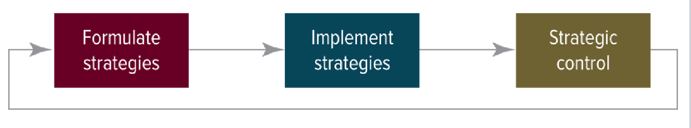

* + Contemporary Approach
    - Relationships between strategy, implementation, and control are highly interactive

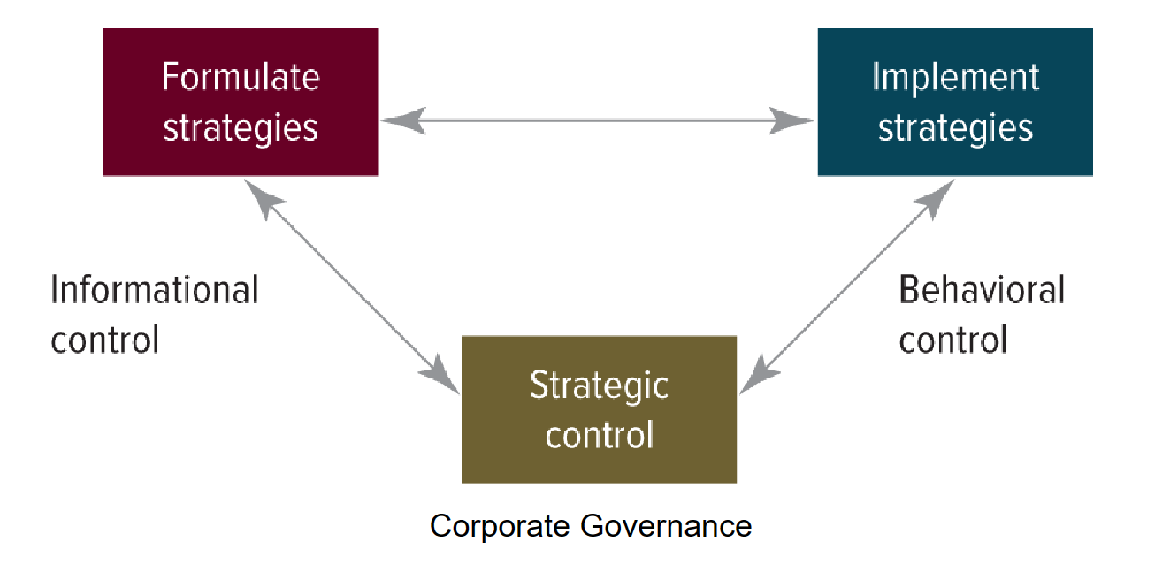

* What are key questions of Informational & Behavioral Controls?
  + Informational control: Is the org doing the right things
  + Behavioral control: Is the org doing things right in in the implementation of strategy
* What is Agency Theory about and what does it recommend?
  + Deals with the relationship between “principals” (Owners) and “agents” (Managers)
    - The goals between principals and agents **conflict**
    - Hard for the principal to verify what agent is actually doing
    - Principal and agent have different attitudes/preferences towards risk
  + Recommends aligning principal and agents interests
    - A committed and involved board of directors
    - Incentives for managers
    - Active engagement from shareholders
* What are two opposing approaches to CEO duality? What are the advantages of each of them?
  + Unity of Command (In favor of duality [ceo and a chairman on board])
    - Provides clear focus
    - Enables quick decisions
    - Eliminates confusion and conflict
    - Enhances a firm's responsiveness
  + Agency theory (In favor of separation)
    - Safeguards against corruption or incompetence
    - Removes conflict of interest
* What are External Governance Control mechanisms?
  + The market for corporate control
    - If shareholders sell→ decreases value of stock→ increases possibility of takeover
  + The auditors who verify the books
  + Banks and Analysts who do research and analysis on firms
  + Governmental regulators
  + The media and public

**Apple business case**

* How did the relationship between Steve Jobs & Apple evolve?
  + Apple computer was founded in 1976, Jobs was the visionary and marketer. Resigned from Apple in 1985 and founded NEXT computer, then Apple bought the next computer in 1997 which brought Jobs back on very intensely, never settling for less than perfect, people who didn’t even know jobs would know what he would want to do, huge motivation came up with all the ideas.
* Provide examples of Informational Control in the Apple case.
  + Top 100 people going to an invite only 3 day strategy session
  + Weekly meetings with executive management team to discuss results strategy, important projects
* What are the three main tenets of Behavioral Control? When should each of them be used?
  + Rewards
    - Objectives are clear
    - Rewards linked to performance/desired behaviors
    - Performance measures highly visible
    - Feedback prompt/ambiguous
    - Perceived as ‘fair’
    - Flexible structure, can adapt to changing circumstances
    - Focus on high priority task
    - Doesn’t have to be $, can be recognition, praise
  + Boundaries
    - Useful in setting specific, measurable objectives, making them achievable, holding managers accountable for implementation
    - Best to use when environment stable/predictable, are largely unskilled, consistency is critical, risk of wrong doing high
  + Organizational Culture
    - System of shared values/beliefs, produces behavioral norms
    - Strong culture leads to engagement provide common purpose/identity, can introduce cure rigidities
    - Sustain by: cultivated, encouraged, fertilized
    - Maintained by story telling, pep talks
* What behavioral controls did Steve Jobs and Tim Cook primarily use and explain why they do so?
  + Steve jobs
    - Boundaries
      * More focused on people doing what he wanted, and doing it right
  + Tim Cook
    - Culture
  + Different strategies of company called for different leaders strategies
* What does the story with the janitor teach us?
  + Reasons matter for why janitor messed up, not for why CEO messed up

**Organizational Design**

* The definition of organization design and what it balances
  + Organizational Design refers to formalized patterns of interactions. It links:
    - People
    - Tasks
    - Technologies
  + It provides a balance between:
    - The need for division of tasks into meaningful groupings
    - The need to integrate these groupings for maximum efficiency
* What does the most appropriate org. structure depend on?
  + Depends on the nature and magnitude of growth as well as the degree of integration needed across businesses as this growth occurs
* How many org. structures are there and how do they evolve?
  + There are 5 Organizational structure
  + Simple Structure develops into functional structure by **growth in revenues and employees**
  + Functional Structure develops into Holding company structure by **diversification into unrelated areas**
  + Functional Structure develops into Divisional/SBU by **Diversification into related products and markets**
  + Holding company structure develops into Divisional/SBU by **Increasing relatedness of products and markets**
  + Divisional/SBU develops into Matrix by **Combining functional departments and product groups into a project basis**
* Characterize each organizational structure: briefly describe it,

draw it, and mention one advantage and disadvantage for each.

**Simple Structure**

* Organization is small, single or very narrow product line
* May foster creativity and individualism
* Advantage
  + Highly informal
  + Centralized decision making
  + Little specialization of tasks
  + Few Rules and regulations
* Disadvantage
  + Responsibilities not understood
  + Self Interest, employees taking advantage of lack of regulation
  + Limited opportunities for upward mobility

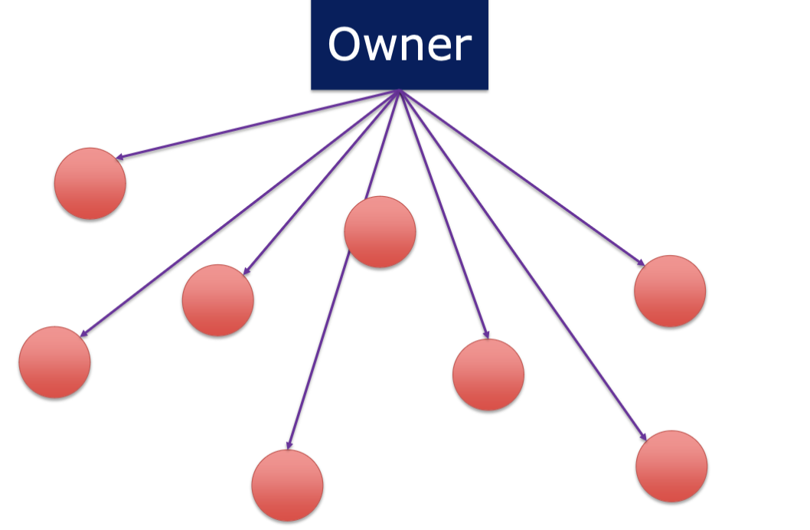

**Functional Structure**

* The major functions of the firm are group internally
* Small organizations with high production volume, and some vertical integration
* Needs specialists in various functional areas
* Advantages
  + Enhanced control
  + Centralized decision making
  + More efficient use of managerial & technical talent
* Disadvantages
  + Impeded communication & coordination due differences in values & orientations - ‘silos’
  + May lead to short term thinking

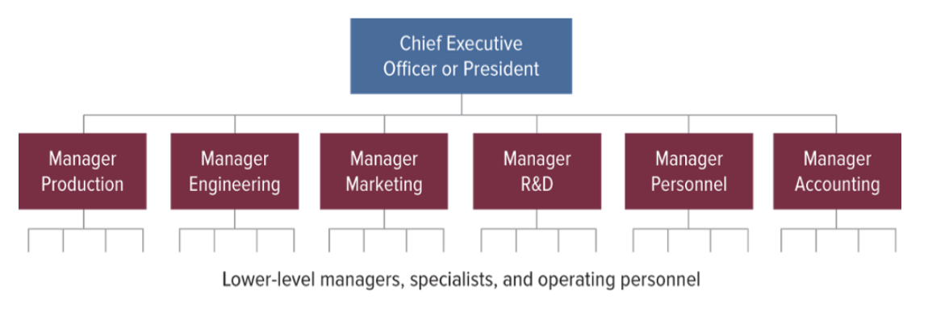

**Divisional**

* Products, projects, or product markets are grouped internally
* Divisions are relatively autonomous
* Each divisions includes its own functional specialists
* Advantages
  + Separation of strategic & operational control
  + Quicker response to changes in the market environment
* Disadvantages
  + Very expensive duplication of functions possible
  + Dysfunctional competition among divisions
  + Differences in image & quality possible across divisions

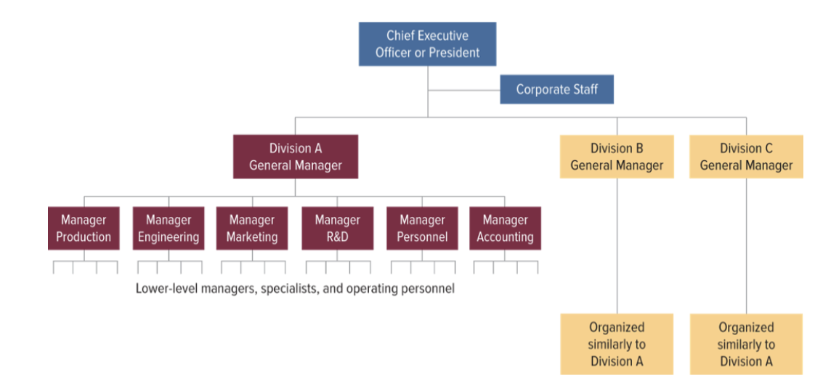

**SBU (Strategic business unit)**

* Similar products or markets are grouped into units to achieve synergy
* Variation on the divisional structure
* Operates as a profit center
* Advantages
  + Planning & controlling by the corporate office
  + Decentralization of authority
  + Quicker response to changes in the market environment
* Disadvantage
  + Possible difficulty in achieving synergies
  + Increased personnel & overhead expenses
  + Corporate office further removed from the divisions

**Holding Company Structure**

* Business in a corporation’s portfolio are the result of unrelated diversification
* Similarities are few
* Advantages
  + Cost savings due to fewer personnel and lower overhead
  + Divisional autonomy increases motivation level of divisional executives
  + Quicker response to changes in the market environment
* Disadvantages
  + Potential for synergies is very limited
  + Corporate office has little control
  + Difficult to replace key divisional executives if they leave
  + Turnaround may be difficult due to limited corporate staff support

**Matrix**

* Functional departments, product groups in a project basis
* Individuals have two managers
* Geographic managers are responsible for profitability of the business in their regions
* Advantages
  + Increases market responsiveness collaboration & synergies
  + Allows more efficient utilization of resources
  + Improves flexibility, coordination & communication
  + Increases professional development
* Disadvantages
  + Dual reporting relationships lead to uncertainty regarding accountability
  + Can lead to power struggles & conflict
  + Relationships are complicated, need team work
  + Decisions making takes longer
* Explain how two reporting lines are organized in a matrix organizational structure to avoid potential conflicts.

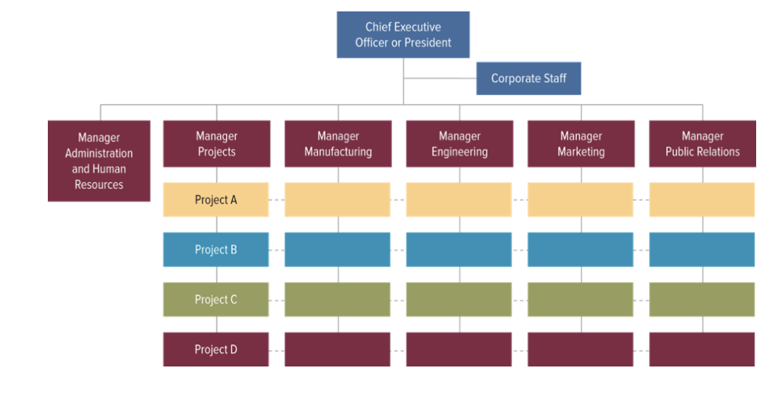

**Ford business case**

* What do you know about Ford’s early development?
  + Started with Model A and produced series of successful vehicles
  + 1908 Henry Ford wanted to create a “Better, Cheaper” car
    - Made the Model T
    - Super Successful
  + Due to the success and demand Ford looked into increasing production and lowering costs
    - Developed a moving assembly line (didn't invent assembly line)
  + By end of 1919 Ford was producing 50% of all cars in the USA
    - Assembly line disruption led to the demise of most of fords rivals
* Share key insights on the strategies of Jacques Nasser, Alan Mulally, and Jim Hackett.
  + Nasser (1990) → When he was CEO really focused on acquisitions of other companies [Volvo, aston martin, land rover, etc]
  + Alan Mulally(2006-2014) → The successor after Nasser was fired. He is famous for starting ‘ONE FORD’. Also famous for divesting all of Nasser's acquisitions.
    - ONE FORD → ‘One team, One plan, One goal’, less is more
  + Hacket→ Focus on innovating vehicles and look at electric vehicles
* What was One Ford about?
  + Smaller and more profitable Ford
    - Get rid of premier auto’s
  + Communicate consistency across all departments, all segments, requiring all people to work together with one plan and one goal
  + Have less products, but increase the quality and amount of the products kept around
* What was the reading on U.A.W. about, and your opinion on it?
* Which organizational structure does each of the following companies use: 1) a start-up, 2) Ford, 3) Procter & Gamble, 4) Berkshire Hathaway (managed by Warren Buffett)?

**Individual Differences**

* Big 5 Personality Traits: describe two opposing sides in each trait
  + Extroversion
    - Reserved vs Sociable
    - Hate being center of attention vs enjoy being center of attention
  + Emotional Stability (Neuroticism)
    - Anxious vs calm
    - Experiencing stress vs Confident
  + Agreeableness
    - Critical vs Empathetic
    - Suspicious vs trusting
  + Conscientiousness
    - Careless vs. hardworking
    - Impulsive vs disciplined
  + Openness (to Experience)(Intellect/Imagination)
    - Conventional vs Curious
    - Practical vs Creative
* Provide several key insights about Personality Traits in general.
  + Think of traits as a Continuum
  + Rather stable over time
  + Nature / Nurture equally
  + Some predictions are possible
  + Predictions
    - Schools performance
    - Gender
    - Marriage
    - Changes over time
    - Delinquency
    - Job performance
    - Leadership
  + Criticism
    - Too broad
    - Missing dimensions
    - Overlap with Temperament
* What is the main idea of Aristotelian Golden Mean? Provide a couple of his examples.
  + The main idea is that excellence is found in between the extremes of both states: Deficiency and Excess.
  + Examples:
    - Coward **Courage** rashness
    - Sloth **Ambition** greed
    - Humility **Modesty** pride
* In “Managing Oneself”, what are the key insights in each of the 7 areas outlined by Peter Drucker?
  + Strengths
    - Build strengths
    - Feedback/reflect
  + How perform
    - Assumes everyone learns same way
    - Writing or talking, better when they work
  + Values
    - Work needs to align with your values
  + Belonging
    - Don’t know where they belong / what they wanna do
  + Relationship
    - Understand other people's strengths
    - All responsible
  + Second half of life
    - Moving into another career path if not happy where you are
    - Way to succeed you need to plan
* What is the Social Media case about and what can we learn form it
  + The case is about Miranda Shaw having a hard time deciding who to hire. She did a google search and found pictures of one of the candidates with his fraternity brothers smoking and drinking and found nothing on their other candidate. She was in a hard decisions as she was leaning towards Parsons as her first option until the pictures surfaced
  + Takes aways:
    - Despite all individual differences, use your common sense on social media
    - Help your employers’ don’t make their job more difficult
    - Your behavior reflects on your organization's reputation. By joining an organization, you become responsible for its reputation as well

**Strategic Leadership**

* What is strategic leadership about, and what are its 5 components?
  + Strategic leadership is the process of transforming organizations from what they are to what the leaders would like them to become according to their Vision
  + 5 Components
    - Performing based on a ‘three-legged stool’
    - Possessing common leadership qualities
    - Leveraging leadership capabilities
    - Using bases of power
    - Demonstrating ethical behavior
* What are common leadership qualities?
  + Proactive
    - Dissatisfied with the status quo
  + Goal Oriented
    - Visualizing successful futures; focused on the creation & implementation
  + Understanding the process
* What do leadership capabilities include? **Which one is the strongest predictor for success at work?** 
  + Technical skills
    - Accounting, operations, negotiations
  + Cognitive abilities
    - Analytical reasoning, quantitative analysis
  + Emotional intelligence
* What does the Emotional Intelligence construct consist of?
  + Self Awareness, Motivation, Social Skill, Empathy
  + Self-regulation
* What is power, its effective uses, and bases of power?
  + Power is a leader’s ability to get things done in a way he or she wants them to be done
  + Effective Use
    - Influence other people’s behavior
    - Persuade them to do things they otherwise would not do
    - Overcome resistance & opposition
  + Bases of power
    - Organizational
      * Legitimate power
      * Reward power
      * Coercive power
      * Information power
    - Personal
      * Referent power
      * Expert power
* What barriers in organizations does a leader need to overcome?
  + Vested interests in the status quo
  + Systematic barriers
    - Obstacles in which the design of organization structure, information processing, and reporting relationships, impede the proper flow and evaluation of information
  + Behavioral barriers
    - Cause managers to look at issues from a biased or limited perspective due to their education, training, work experiences, and so forth
  + Political barriers
    - Refer to conflicts arising from power relationships
  + Personal time constraints

**Procter & Gamble business case**

* What changes did AG Lafley make during his first term?
  + Innovation was led by consumers
  + Created innovation
  + Differentiated products
  + Redesigned the organization
    - Relocated executive offices
    - Replaces managers
    - Promoted women
    - Tracked and trained lower level employees (prepared them for promotion)
  + How consumers view and experience the product
* How did AG Lafley overcome Barriers to Change at P&G?
  + Allowed the managers and the employees to participate in and take responsibility for his proposed changes (addressed status quo)
  + He did not push for specific changes without giving a chance for the other people in the organization to get involved (systematic barriers)
  + He helped shape decisions by asking a series of keen questions (behavioral barriers)
  + He kept patiently communicating what he would like to see done differently (time constraints)
* What is innovation at P&G according to AG Lafley?
  + Not just Product and technology, it’s how consumers view and experience it: brand shopper experience, usage experience, business model, going to market, and supply chain
* What vision did Bob McDonald come up with and why did it not work?
  + His vision was ‘Purpose-inspired growth’. Turned out to be hard to implement during the rescission
  + Recession battered consumers
  + Surging commodity prices
  + Premium priced products
  + Reduced margins
  + Frustrated shareholders
  + Focus on operational efficiency
    - Considered employees
    - Stalled innovation engine
    - Lowered morale
    - Some key employees left the firm
* **How did Morris Chang at TSMC demonstrate strategic leadership?** 
  + He demonstrated great leadership by having a strong Vision and ability to implement it .

**Teamwork**

* What is your Myers-Briggs personality type?
  + ENTP
* In the MBTI framework, characterize what S, N, T, F, J, P stand for, and what key Strategic questions they explain.
  + How do you prefer to take information?
    - S: Sensors→ Focus on reality of how things are,pay attention to concrete facts/details
    - N: Intuitives→ imagine possibilities of what things can be, notice the big picture and how things connect
  + How do you prefer to make decisions?
    - T: Thinkers→ use logical reasoning, value fairness and justice, reasonable and level-headed
    - F: Feelers→ Decisions are based on values and how others would be affected, empathetic, value harmony and forgiveness
  + How do you prefer to live outer life?
    - J: Judgers→Prefer to have matters settled, think rules and deadlines should be respected, like to have plans to know what is going on, like step by step instructions
    - P: Perceivers→ Like to keep options open, like to improvise, see rules and deadlines as flexible, spontaneous
* Who fits the Key Leader Behaviors framework better: Kobe Bryant or Tim Duncan? Why do you think so?
  + Probably Tim Duncan. The Key leader behaviors have 3 components to it: Relational, task, and change behaviors. Relational involves making a team a nice place to be and developing trust and getting to know people. This favors Tim because he had better relationships. For the Task behaviors Tim and his team knew their roles and trusted people to do their job whereas Kobe oftentimes would just take over because he thought himself to be better. For Change behaviors it involves communication, insight, and feedback which Tim was more receptive of and allowed for a more comfortable space to do this.
* What are the three classic criteria that can help you evaluate your team effectiveness? What does each criterion include?
  + Output
    - Are customers happy with the output? (Quality, quantity, delivery)
  + Collaborative Activity
    - Do our teams dynamics help us work well together
  + Individual Development
    - Are individual team members building their knowledge, skills, and abilities
* What are the four conditions for building an effective team? What exactly does each condition require?
  + Compelling Direction
    - Is there a common goal that is clear to everyone?
  + Strong Structure
    - Do we have the right number and mix of people
    - Are people responsible for tasks from start to end
    - Clear norms for acceptable output
  + Supportive Context
    - Do we have the resources, information, and training needed?
    - Are there appropriate rewards for success?
  + Shared Mindset
    - Do the team members have a strong common identity
    - Do we readily share info with team members and understand everyone's constraints?

**Business Ethics**

* What are the major moral theories and what are the key ideas of each moral theory?
  + Utilitarianism (Bentham/Mill)
    - Focuses mostly on consequences
    - The greatest amount of good for the greatest number of people
    - The end justified the mean
  + Deontology (Kant)
    - Acting on those principles whose universal acceptance you could prescribe to everyone
    - Everyone's duty is to follow the universal rules
    - Morality is about following an intent to fulfill your duty
  + Virtue Ethics (Aristotle)
    - Building a good character where moral behavior comes naturally, out of propensity to do good
    - Good character is built by practicing virtuous actions
    - Practice forms a habit which becomes part of one’s character
  + Ethics of Care (Gilligan)
    - Developed in stark contrast to the idea that moral development is based on moral reasoning
    - Has feminine underpinnings
    - Morality is about caring for people around you
  + Pragmatism (James Dewey)
    - No universal rules, the context of a problem matters
    - Avoiding false dichotomies (fact vs value, theory vs practice)
    - Emphasizes the betterment of our lives
    - Anything that doesn’t contribute to ameliorating our way of life should be avoided (futile discussions)
  + Rawlsian Veil of Ignorance
    - We should develop fair governing norms for our society from behind a veil of ignorance - without knowing our places in the social order ,gender, race, status
* What is the relationship between ethical and financial performance in organizations?
  + Positive relationships have generally been found between ethical performance and strong organizational culture, increased employee efforts, lower turnover higher organizational commitment and enhanced social responsibility
* What are the two main ethical frameworks in business?
  + Compliance based Ethics program
    - Prevents, detects & punishes legal violations
  + Integrity based ethics program
    - Enables ethical conduct
    - Examines organizational members core guiding values, thoughts, & actions
    - Defines responsibility & aspirations for ethical conduct

**Danville Airlines case and Western companies in Russia**

* What is the Danville Airlines case about?
  + The Danville Airlines HR director found out that David Reiger, one of their best pilots, dad had recently passed away from Huntington's disease.This is a genetic disease that results in the patient having uncontrollable muscle spasms and eventually dying. The HR director took his blood for a routine drug and alcohol test and sneakily got it tested for the gene to see if he had the disease.
  + Danville is left with a decision to let Reiger go because of the possible risk of allowing him to fly with the condition or whether they keep him on as a pilot
* What are main takeaways from the Danville Airlines case?
* Which moral theory would you apply to decide on the future role of the pilot?
  + I think Rawlsian Veil of Ignorance. I think this is the most fair for people in this type of situation. I do however believe there should be increased physicals and monitoring on the pilot.
* What are key considerations for Western companies in Russia?
* What should be part of business discussion when deciding on whether to operate in Russia?

**Innovation**

* Why does Innovation matter?
  + The use of new knowledge to create new & commercially viable products and services, transform organizational processes, and can help enhance different experiences.
* What is the difference between incremental, radical, sustaining, and disruptive innovation?
  + Incremental
    - Enhances existing practices by making small improvements in products & processes
  + Radical
    - A result of technological change, it can revolutionize a whole industry
  + Sustaining
    - May be incremental or radical innovations, but it extends sales in an existing market. It also enables new product or services to be sold at higher margins (via the internet)
  + Disruptive
    - This is a new approach to meeting customers' needs. It often goes beyond existing industries. It tends to be technologically simpler & less sophisticated. Appeals are toward less demanding customers, but it takes time to take effect.
* How do such pieces as Project Definition, Project Impetus, Product Champion, and Exit Champion fit together?
  + Project Definition
    - The attractiveness in the marketplace
  + Project Impetus
    - Approved, and the resources and allocated)
  + Product champion
    - Scavenge for resources and encourage other to back promising new ideas
  + **Exit champions**
* When can Real Options Analysis help and how does it work?
  + It is used when launching a new venture and needs help managing the uncertainty with it.
  + **How does it work?**
* What does Self-Determination Theory explain and what are its 3 focal components?
  + It explains the intrinsic motives and needs inherent in human nature
  + 3 Focal Points
    - Autonomy
      * The feeling one has choice and willingly endorsing one’s behavior
    - Competence
      * The experience of mastery and being effective in ones activity
    - Relatedness
      * The need to feel connected and belongingness with others

**Samsung business case**

* What is the Samsung story about?
* Provide one example of Yun’s innovative action in each of the following functional areas: HR, R&D, Operations, Finance, & Marketing.
* How did Samsung resolve 5 innovation dilemmas?
* Did Samsung use a focused or dispersed approach to innovation?